Mrs. Cineus’ Wonder’s Weekly To-Do List
- Unit 4 Week 3 – May 4th –May 8th
- Once worksheet pages are complete screenshot with electronic device and send via remind.
- Assignments can be turned in as students complete them or all at one time, whichever is convenient for you
- Everyday students should complete 20 minutes and 20 minutes of I-Ready Reading.
Monday | Tuesday | Wednesday | Thursday | Friday
- Complete pages 173-175 from Your Turn Book.  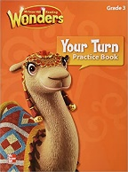 | - Complete pages 412-415 from Ready job. Complete the “write” question.  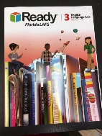  - Complete pages 177-178 from Your Turn Book. | - Complete pages 138-141 from Ready Book. Number 9 is optional. | - Read the assigned story “Making the Moose out of Life: in student mailbox and take quiz use the link below. Don’t forget to take an AR test  https://www.getepic.com/students  Class code: pra0590  - Complete “Where is Mario’s Baseball Glove? ” from workshop folder,  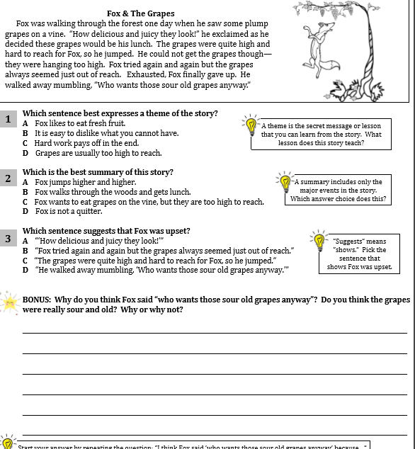 | Social Studies Assignment:  - Watch the Video about the state of Alabama and New York and write 3 interesting fact in your journal.  https://www.youtube.com/watch?v=hWxAeRnpDns  https://www.youtube.com/watch?v=uw6rz_LiTzU  Have a great weekend!

